**CLOUD COMPUTING AND BIG DATA ANALYTICS EXPERIMENTS**

**EXP NO 1: CREATE A SIMPLE CLOUD SOFTWARE APPLICATION AND PROVIDE**

**IT AS A SERVICE USING ANY CLOUD SERVICE PROVIDER TODEMONSTRATE**

**SOFTWARE AS A SERVICE (SAAS).**

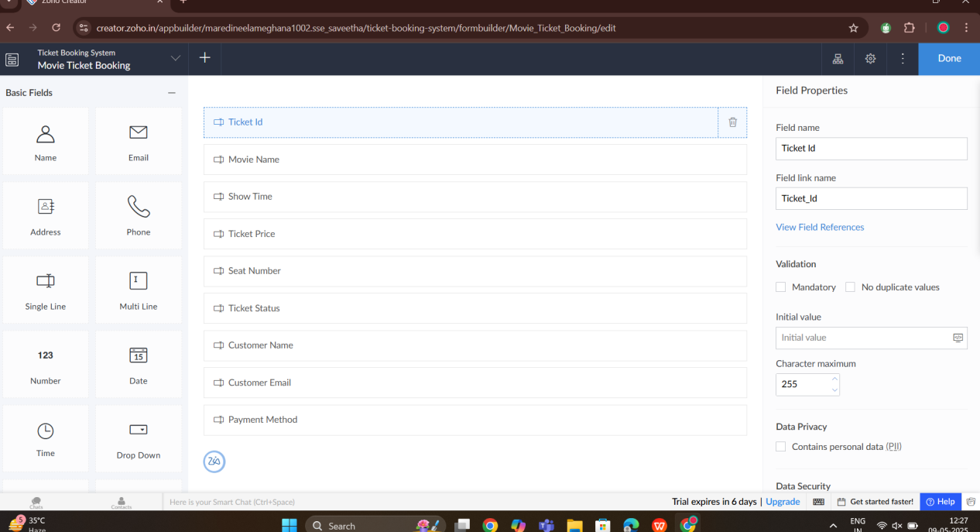

**EXP 2 : FLIGHT RESERVATION SYSTEM - SAAS**

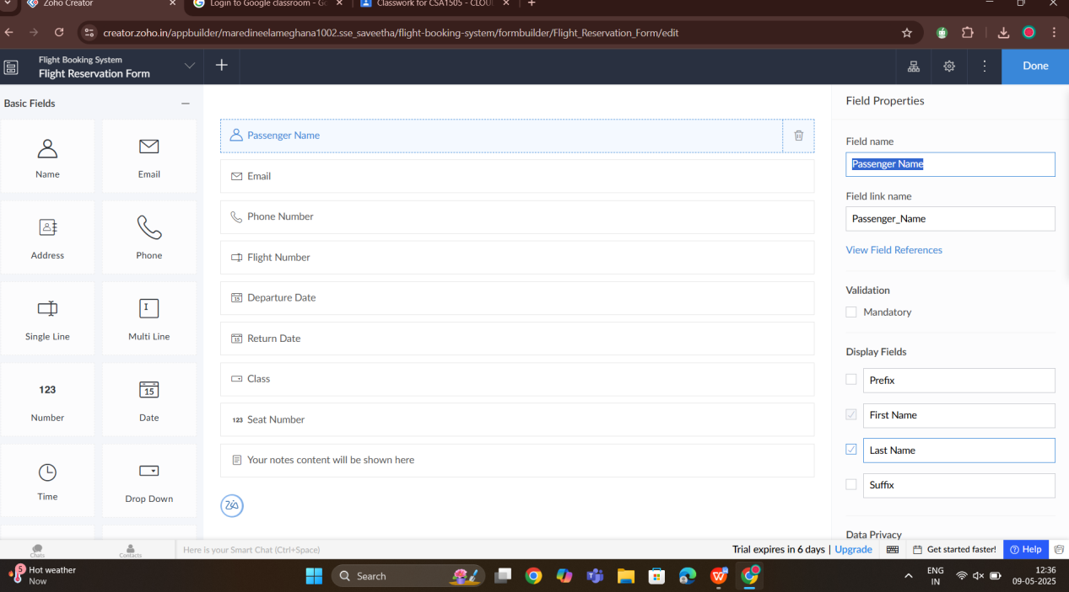

**EXP NO 3: CREATE A SIMPLE CLOUD SOFTWARE APPLICATION FOR PROPERTY BUYING & RENTAL PROCESS (IN CHENNAI CITY) USING ANY CLOUD SERVICE PROVIDER TO DEMONSTRATE SAAS.**

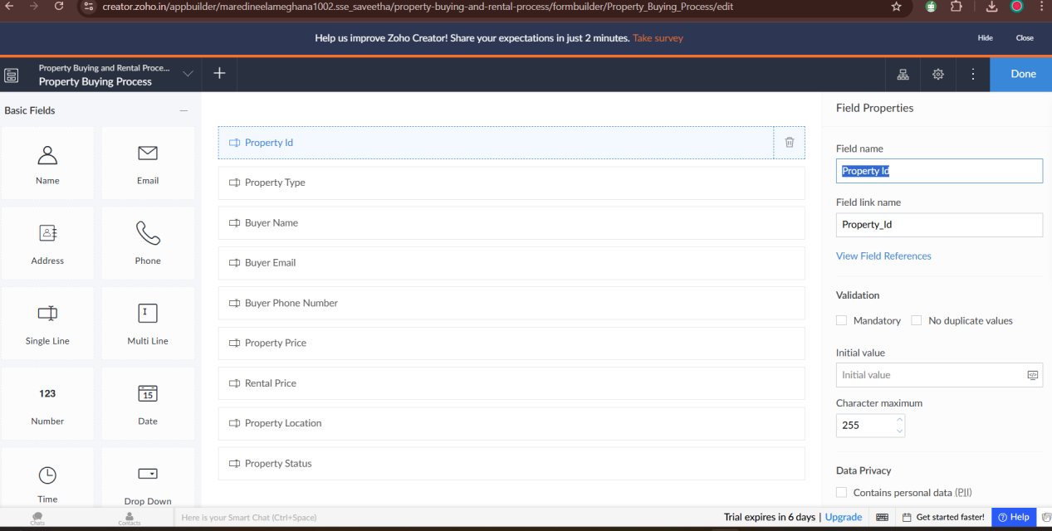

**EXP NO 4: CREATE A SIMPLE CLOUD SOFTWARE APPLICATION FOR CAR BOOKING RESERVATION SYSTEM USING ANY CLOUD SERVICE PROVIDER TO DEMONSTRATE SAAS.**

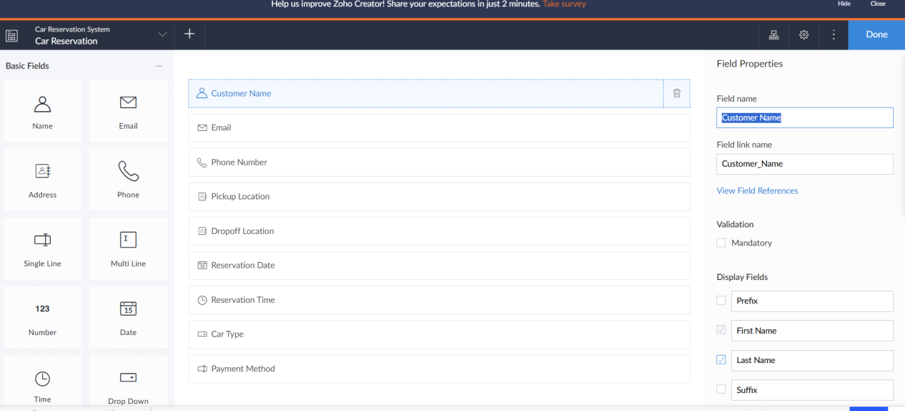

**EXP 5 : LIBRARY BOOK RESEVATION SYSTEM - SIMATS**

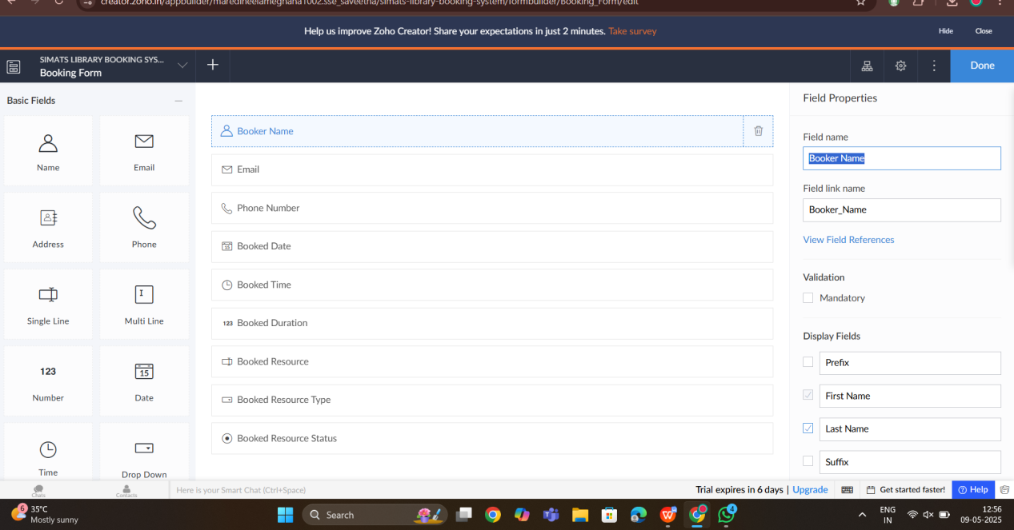

**EXP 6 : PRODUCT SELLING CLOUD SERVICE PLATFORM**

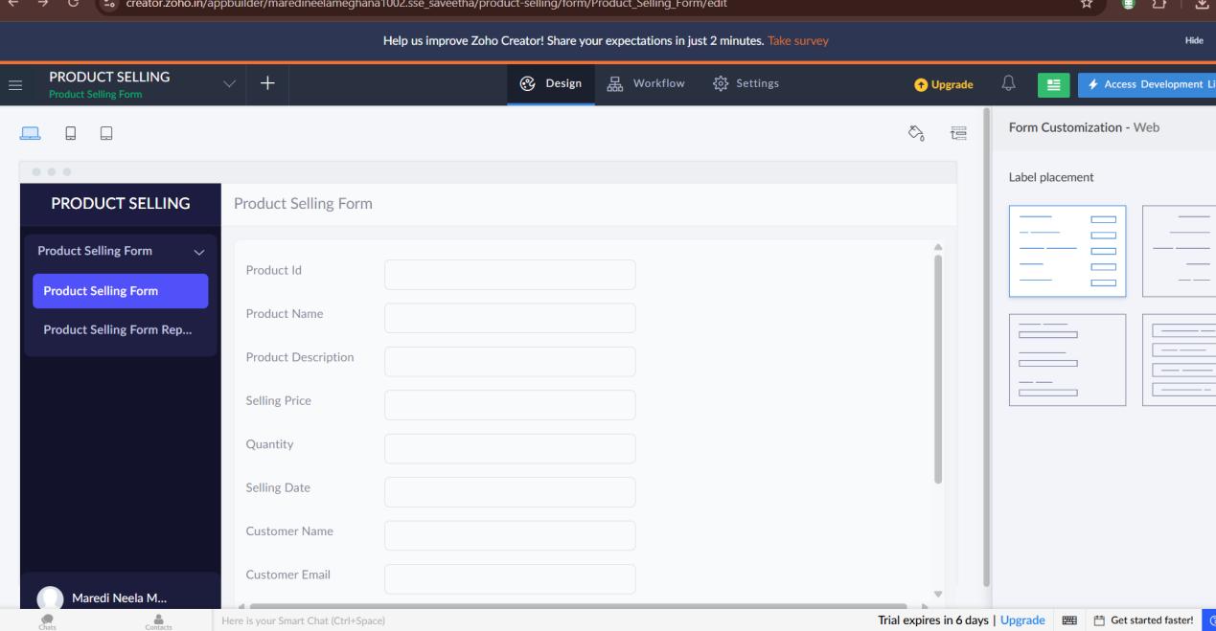

**EXP NO 7: DEMONSTRATE VIRTUALIZATION BY INSTALLING TYPE-2 HYPERVISOR IN YOUR DEVICE, CREATE AND CONFIGURE VM IMAGE WITH A HOST OPERATING SYSTEM (EITHER WINDOWS/LINUX).**

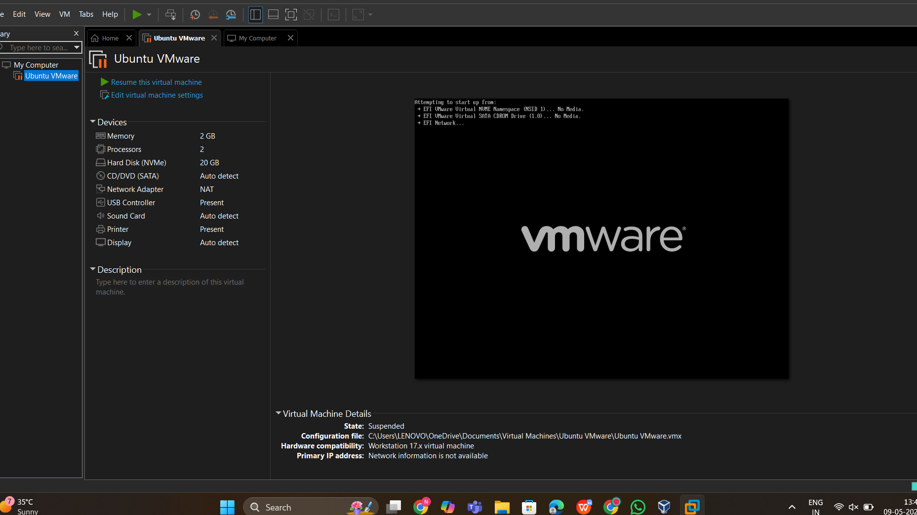

**EXPNO 8: CREATE A VIRTUAL MACHINE WITH 1 CPU, 2GB RAM AND 15GB STORAGE DISK USING A TYPE 2 VIRTUALIZATION SOFTWARE.**

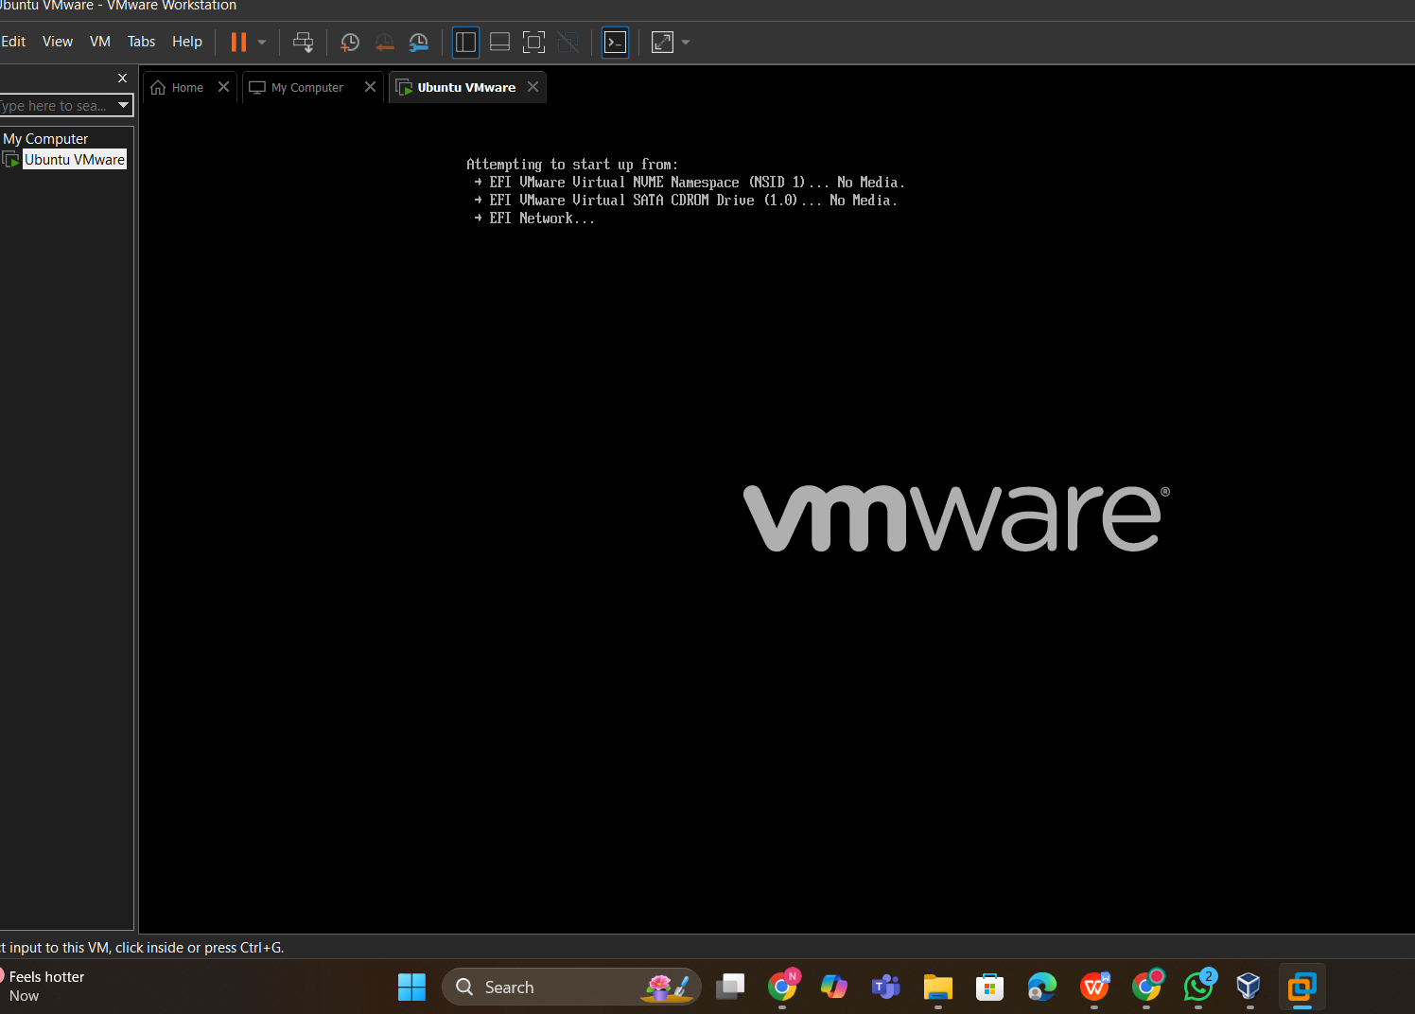

**EX 9 : CREATE A VIRTUAL HARD DISK AND ALLOCATE THE STORAGE USING VMware WORKSTATION**

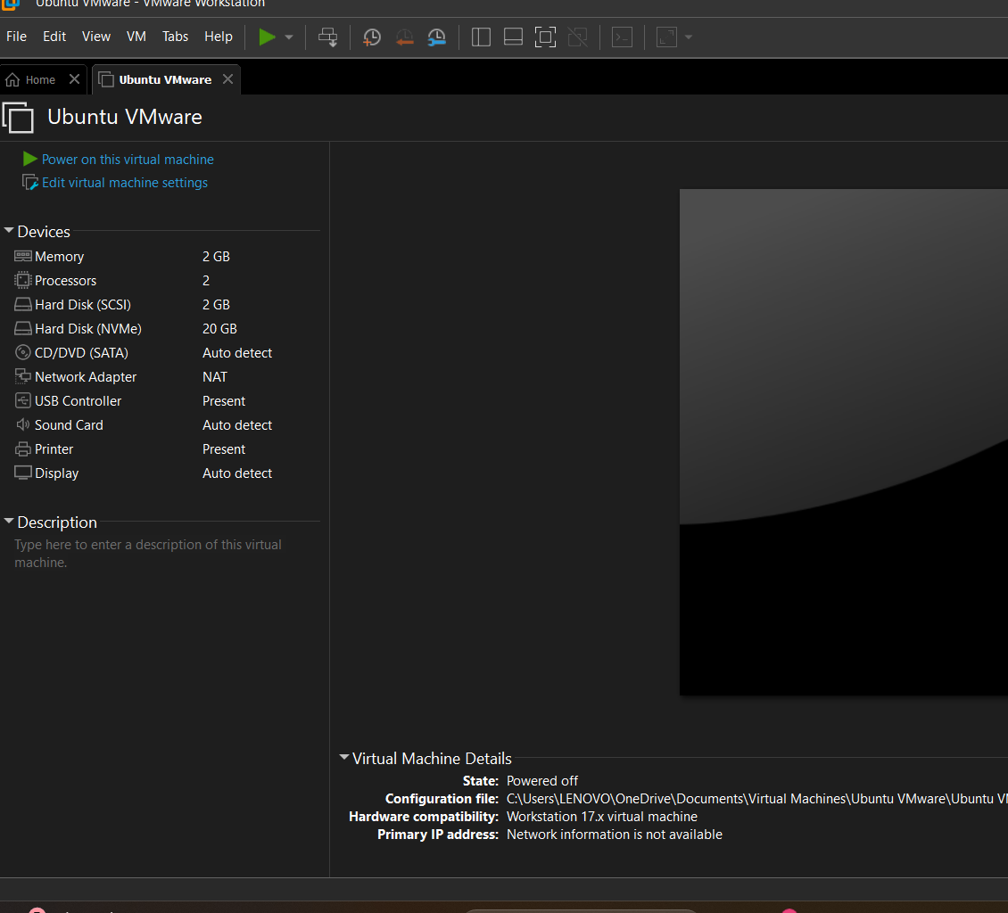

**Exp 10 : CREATE A SNAPSHOT OF VM AND TEST IT BY LOADING THE PREVIOUS VERSION/ CLONED VM**

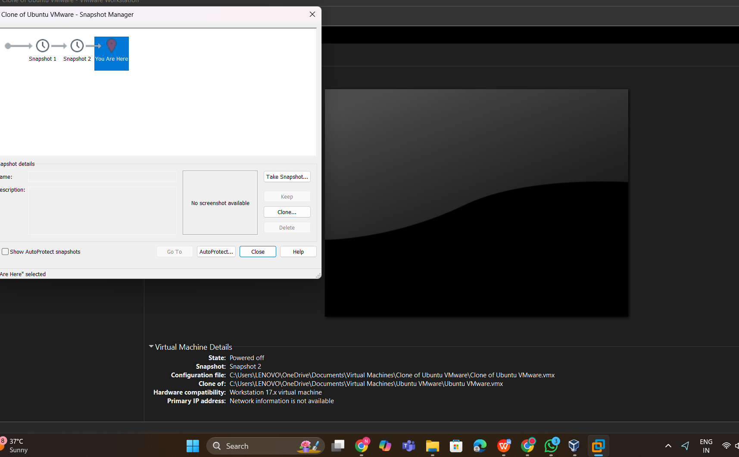

**EXP 11 : CREATE A CLONING OF VM AND TEST IT BY LOADING THE PREVIOUS ONE**

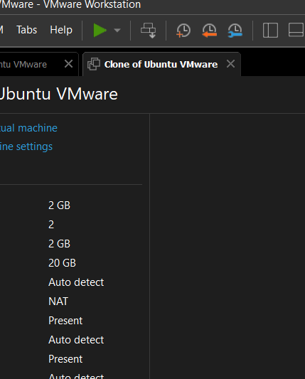

**EXP 12 : CHANGE THE HARDWARE COMPATIBILITY OF A VM WHICH IS ALREADY CONFIGURED**

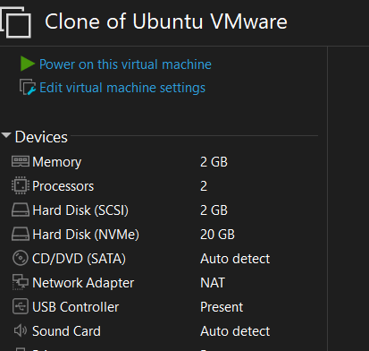

**13. Create a Virtual Machine with 1 CPU, 2GB RAM and 15GB storage disk using a Type 2**

**Virtualization Software using Vmware workstation.**



1. **Create a Virtual Hard Disk and allocate the storage using Vmware Workstation.**



1. **Create a Snapshot of a VM and Test it by loading the Previous Version/Cloned VM using Vmware workstation.**



1. **Create a Cloning of a VM and Test it by loading the Previous Version/Cloned VM using vmware workstation.**



1. **Change Hardware compatibility of a VM (Either by clone/create new one) which is already created and configured using vmware workstation.**

